## Getting Up and Running with the Power BI Service

**Setup Time**: 60 minutes

**Lab Folder**: C:\Student\Modules\01_Intro\Lab

**Overview**: This lab will teach you how to get up and running with the Power BI service to prepare for Power BI development. You will start by copy the student files to your local workstation. Next, you will log into an Azure AD user account that has been created for you in an Azure AD tenant shared by all students which has a domain name of **powerbimvps.onmicrosoft.com**. Once you have logged into the Power BI service and started your 60 Power BI Pro trial, you will be able to upload PBIX files into your personal workspace and you can begin designing dashboard and reports in the browser. The lab will also step you through downloading and installing Power BI Desktop as well as publishing a Power BI Desktop project to the Power BI service. You create a new app workspace and populate it with a dataset, a report and a dashboard. In the final exercise, you will use the Publish to Web feature together with Visual Studio to embed a Power BI report in a custom web page.

### Exercise 1: Copy the Student Lab Files to Your Local PC

Student files for this course are maintained in a GitHub fil repository at <https://github.com/CriticalPathTraining/DevInADay>. You will download the student files from there so you have a local copy on your PC workstation.

1. Navigate to the github repository for this workshop at <https://github.com/CriticalPathTraining/DevInADay/>.

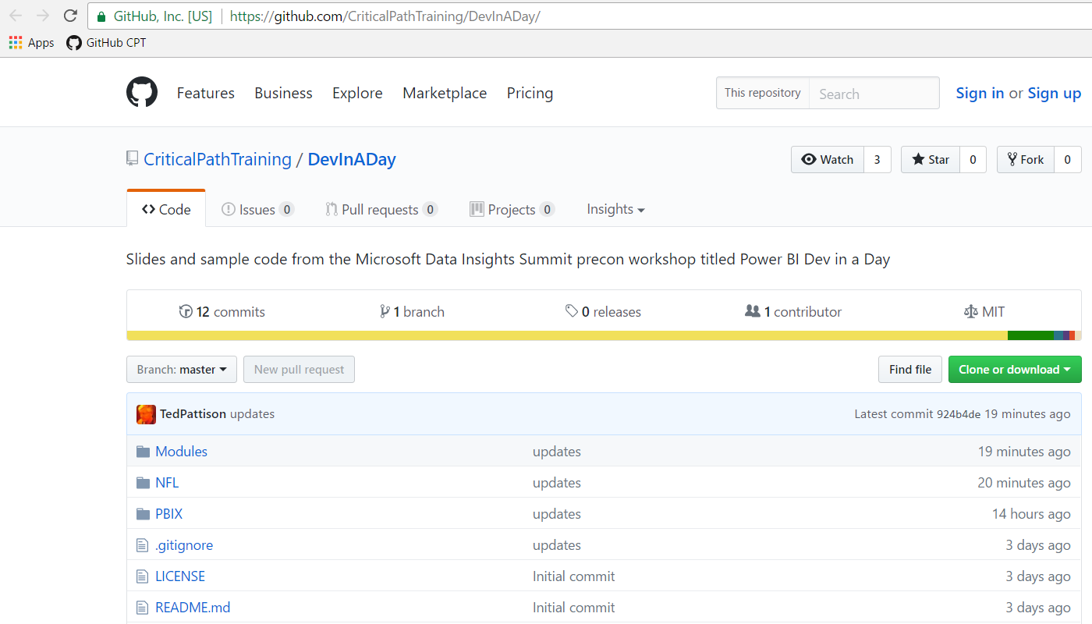

1. If you have GIT installed, you can run the following command to automate downloading the student files to your PC.

git clone https://github.com/CriticalPathTraining/DevInADay.git c:\Student

1. If you do not have GIT installed, you can download the master zip archive and extract the contents in a local folder.
   1. Click on the following link: <https://github.com/CriticalPathTraining/DevInADay/archive/master.zip>.
   2. Once you have downloaded this zip archive you can extract the contents into a local directory named **C:\Student**.
2. You should have now copied the student files for this workshop into a local folder named **C:\Student**.

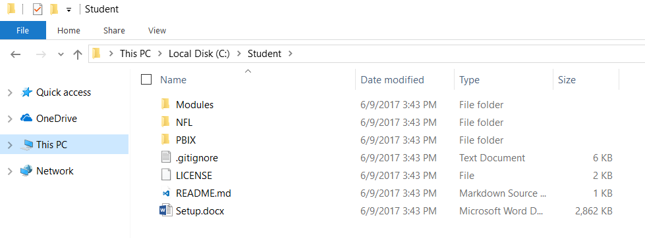

### Exercise 2: Log into your User Account and Access the Power BI Service

In this exercise, you will log into an Azure Active Directory account that has been created for you to work inside the Power BI environment to complete the lab exercises for this workshop. The account you will use has been created in an Azure AD tenancy with a domain of **powerbimvps.onmicrosoft.com**. Once you log in, you will be prompted to accept a Power BI Pro trial for 60 days able to access the Power BI service. Once you accept the 60 day trial, you will be able to access your personal workspace and begin creating datasets, reports and dashboards.

1. Make sure you have obtained the following information from the instructor about your user account:
   1. user account name (e.g. **CritialPathUser42.powerbimvps.onMicrosoft.com**)
   2. Password: **Pass@word1**
2. Log into the Power BI service using your new user account.
   1. Open a browser such as Chrome, Edge or Internet Explorer.
   2. Navigate to the following URL:

<https://app.powerbi.com>

* 1. When prompted to sign in, enter the user account name that has been provided to you and a password of **Pass@word1**. Click the **Sign in** button to begin the initial log in sequence.

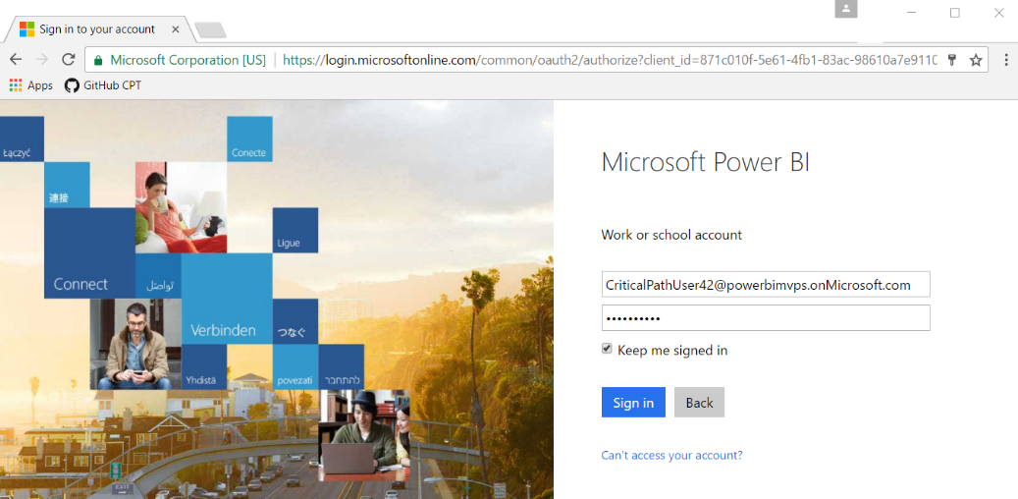

* 1. When prompted to update your password, enter a new password that you can remember for the entire day of this workshop ;)

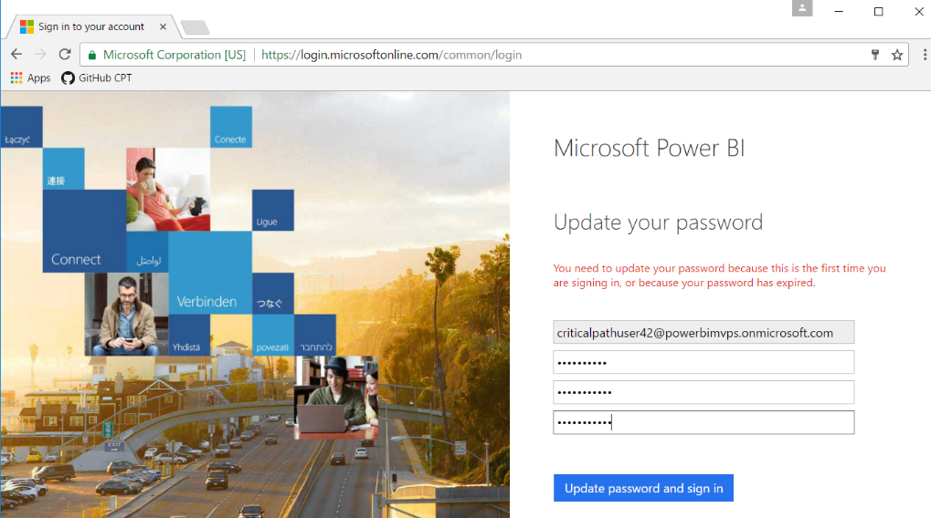

* 1. You should now be prompted with a Power BI Sign in page. Click **Sign in**.

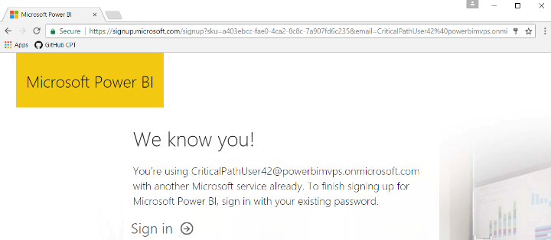

* 1. Next click the **Start** button.

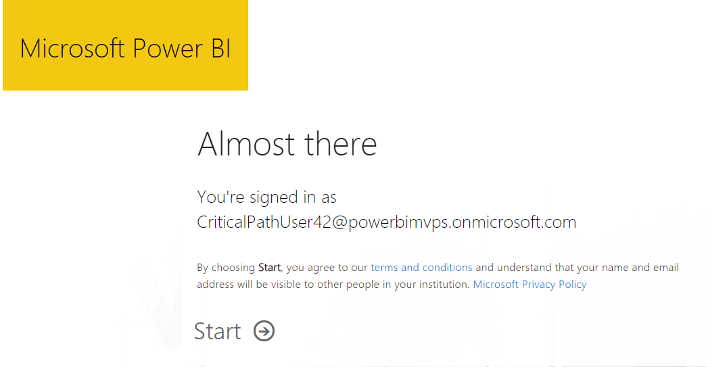

* 1. Skip by the next page which asks if you want to invite more people.

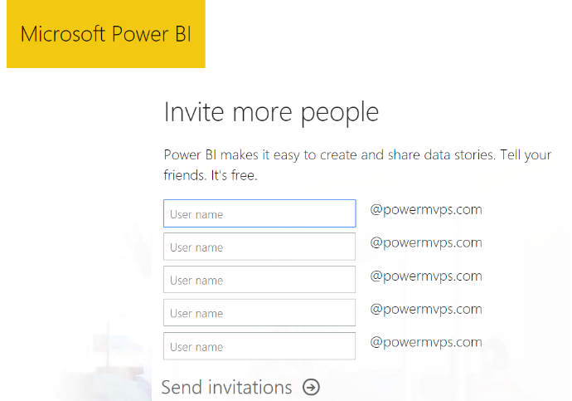

* 1. When you see the **Welcome to Power BI** dialog as shown in the following screenshot, click the **Yes, start trial!** Button.

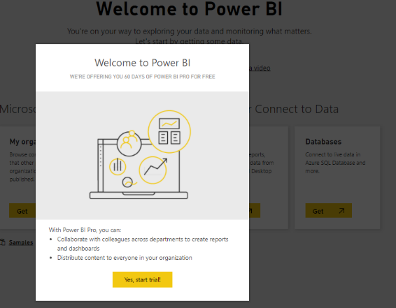

* 1. You should now be signed into Power BI and running within your personal workspace.

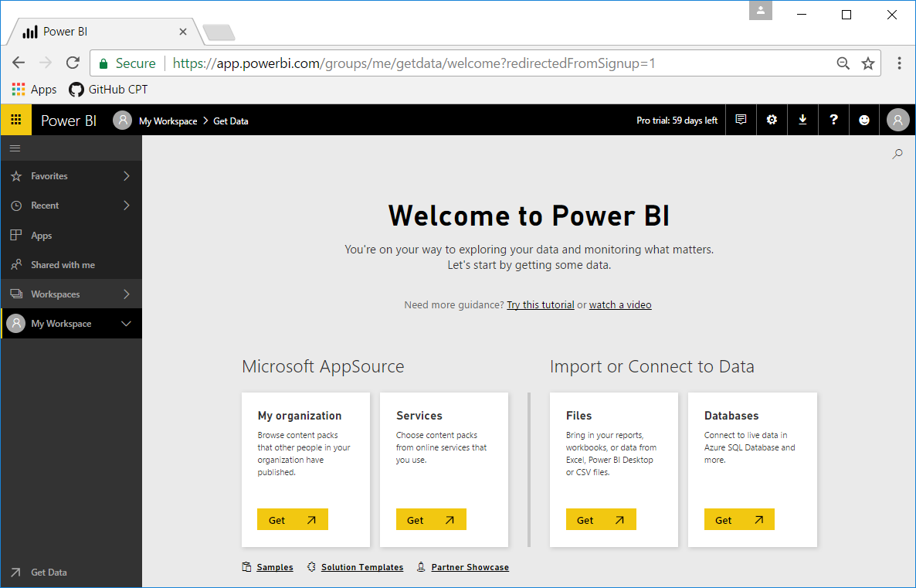

### Exercise 3: Upload a PBIX File to Your Personal Workspace

Now that you are signed in as a Power BI Pro user, you can begin working with Power BI to create new datasets, reports and dashboards. In this exercise, you will import a PBIX project file into your personal workspace to create a new dataset and report.

1. At this point, you should be at the **Welcome to Power BI** page where you were at the end of the previous exercise.
2. Import a PBIX project file into your personal workspace.
   1. Click in the **Get** button in the **Files** tile under the **Import or Connect to Data** section header.

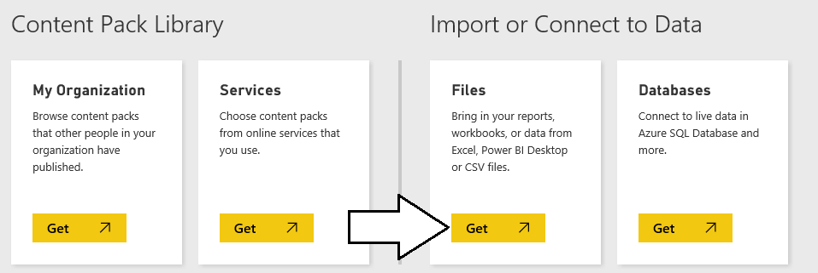

* 1. On the next page you should see several tiles which indicate your choices for the location of the file you would like to connect to or import. Click on the tile with the caption **Local File** so you can import a PBIX file from inside your student folder.

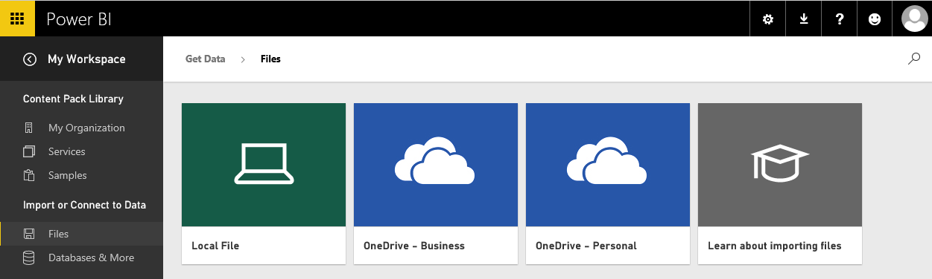

* 1. When prompted with the **Open** dialog, select the PBIX file named **C:\Student\PBIX\Wingtip Sales Analysis.pbix** and then click **Open**.

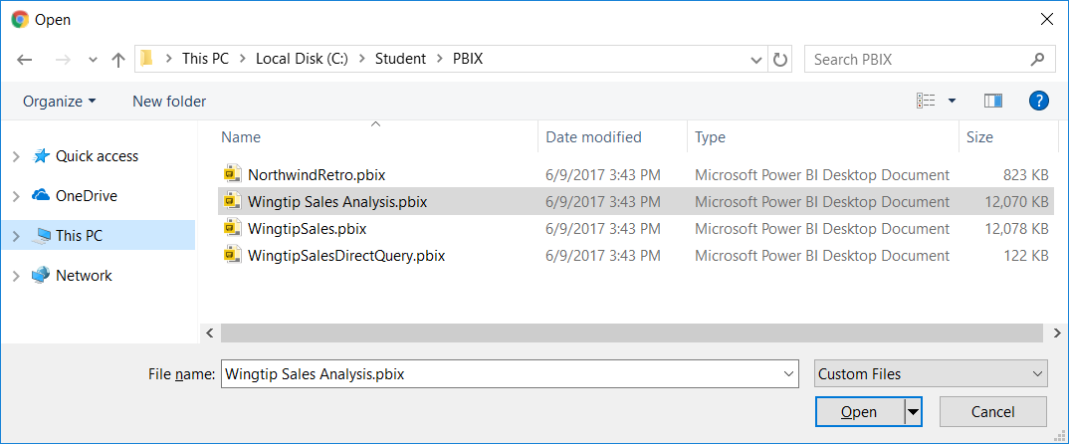

* 1. It will take the Power BI services a few seconds to complete the upload.

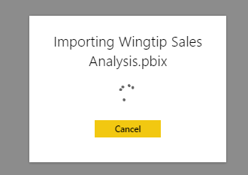

1. When the PBIX import process completes, inspect what content has added to your personal workspace.
   1. You should be able to see that the Power BI service has created a new dashboard with the same name as the PBIX file which in this case is **Wingtip Sales Analysis.pbix**. Click the **Delete** icon to delete this dashboard.

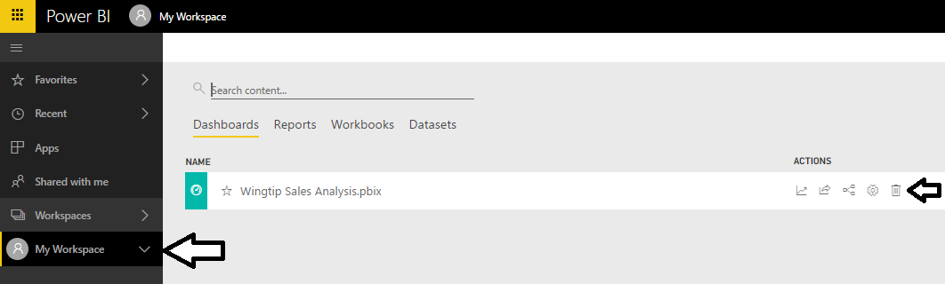

* 1. Navigate to the **Datasets** view and verify you can see a new dataset named **Wingtip Sales Analysis**.

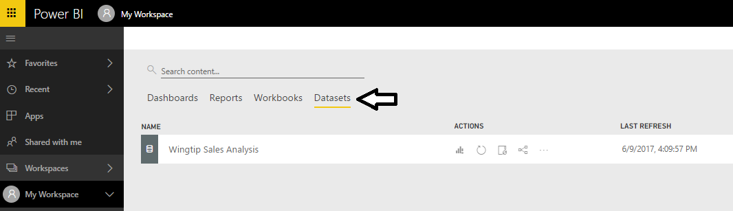

* 1. Navigate to **Reports** view and verify you can see a new report named **Wingtip Sales Analysis**. Click on the report to open it.

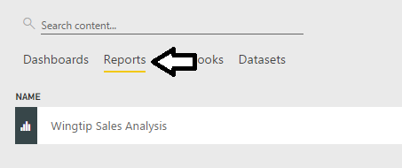

* 1. When the report opens, take a minute and inspect each of the pages in the report.

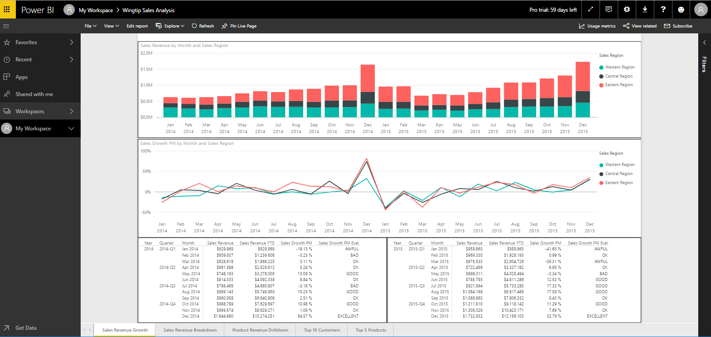

1. Create a new dashboard named **Wingtip Sales Analysis**.
   1. Return to the page named **Sales Revenue Growth**.
   2. Hover the mouse over the top right corner of the line chart visual and click the thumbtack to pin the visual to a dashboard.

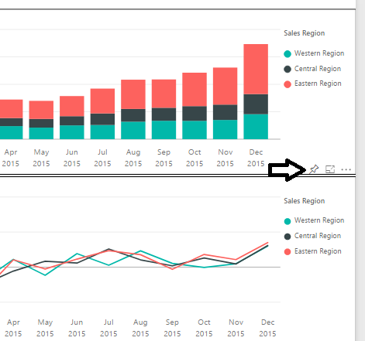

* 1. In the **Pin to dashboard** dialog, select **New dashboard** and give it a name of **Wingtip Sales Analysis**. Click the **Pin** button to create a new dashboard and add a new tile based on the line chart visual.

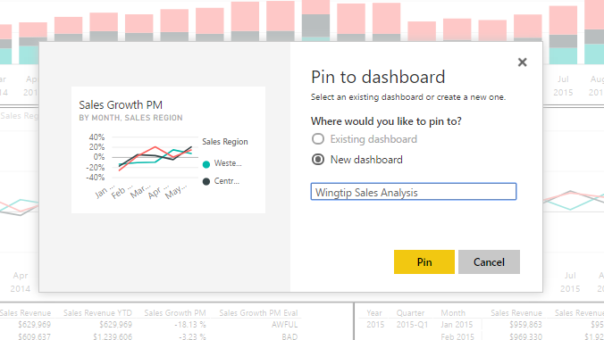

* 1. The Power BI service will display a notification when the dashboard and tile have been created.

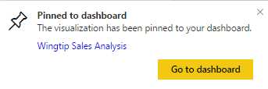

* 1. Navigate to the new dashboard which should appear as the one shown in the following screenshot.

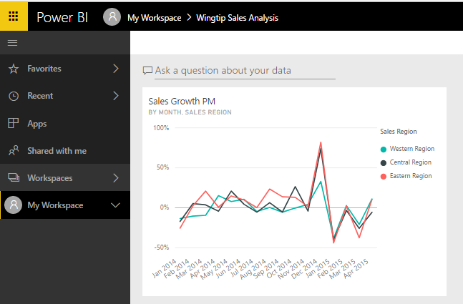

* 1. Resize the dashboard tile to make it wider.

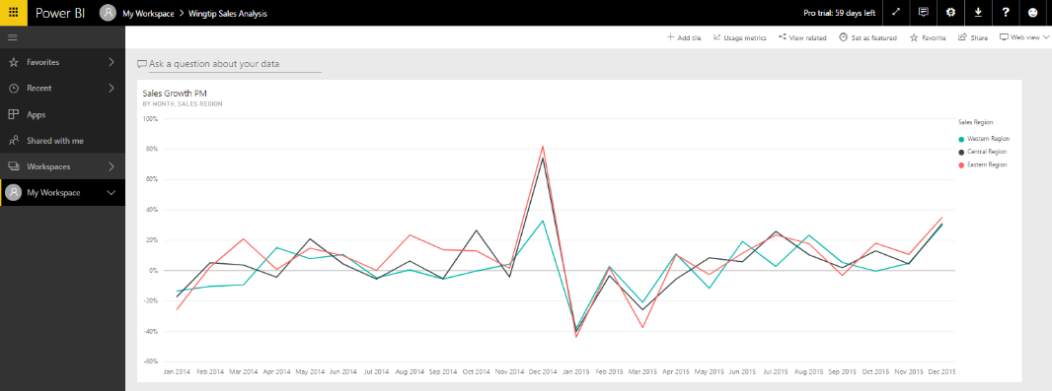

* 1. Return to the report and pin another 3-4 visuals to fill the dashboard up with a few more tiles. Try to make your dashboard look like the one shown below.

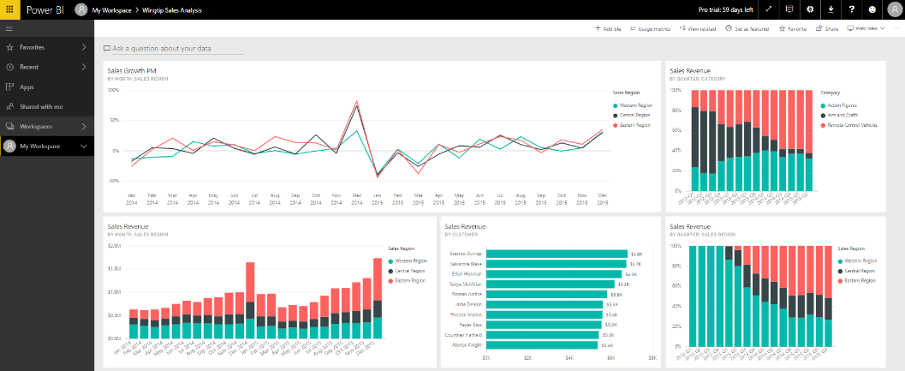

Don’t spend too much time trying to make the dashboard look pretty. At this point, it’s just important that you know how to create a dashboard and fill it with tiles created from report visuals.

### Exercise 4: Install and Configure Power BI Desktop

In this exercise, you will download and install Power BI Desktop. Note that if Power BI desktop is already installed on your developer workstation, you can skip this exercise and move ahead to exercise 5.

1. On the top right of the Power BI service window, drop down the **Downloads** menu and click the **Power BI Desktop** menu command to begin the download of the installation file.

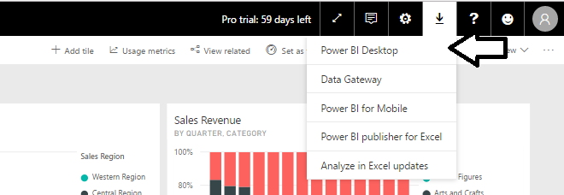

1. Wait for the MSI file to download.



1. Once the file has downloaded, click the **Run** button to begin the installation of Power BI Desktop.



1. When you see the Welcome screen, click **Next** to continue with the installation.

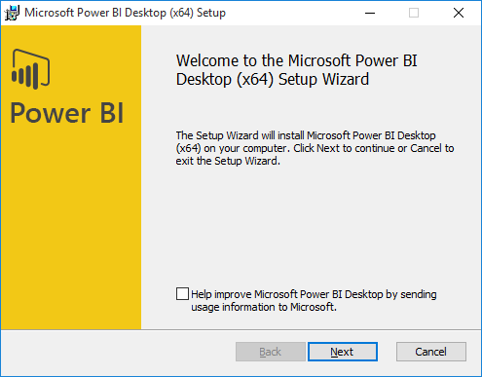

1. Click the checkbox to accept the license agreement and click **Next**.

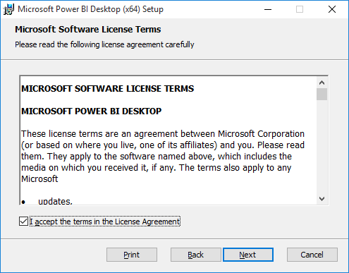

1. Accept the default location for the installation and click **Next**.

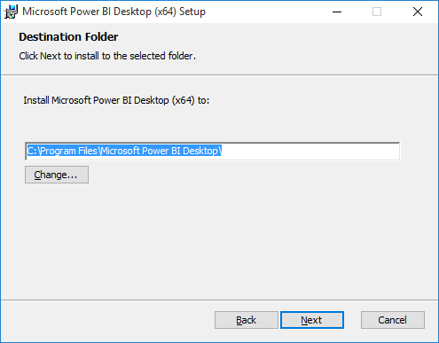

1. On the next screen, click **Install**.

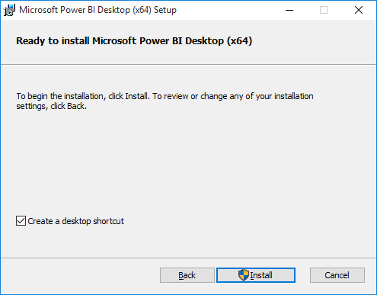

1. When you see the **Completed the Microsoft Power BI Desktop Setup Wizard** screen, click **Finish** to launch Power BI Desktop.

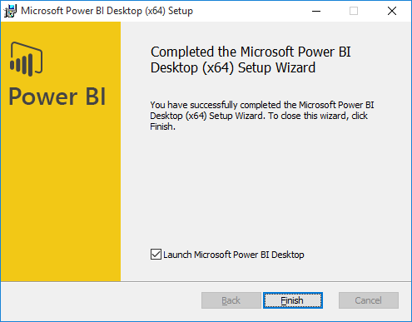

1. When Power BI Desktop launches for the first time, it displays a Welcome screen as shown in the following desktop. Click the (**X**) button in the upper right corner to close this window.

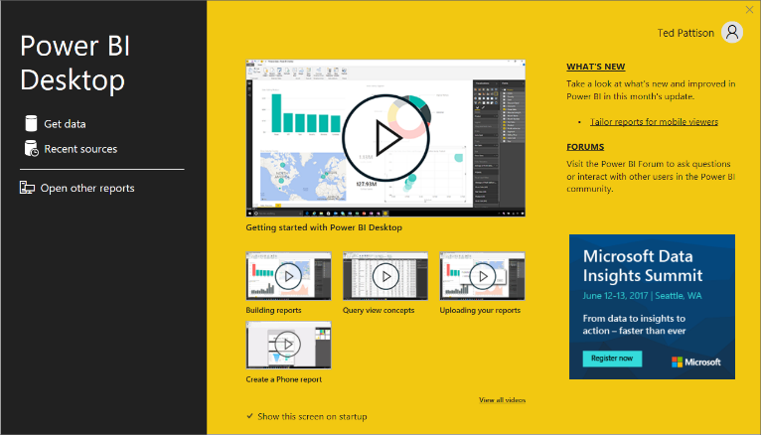

1. At this point, you should have Power BI Desktop running as shown in the following screenshot.

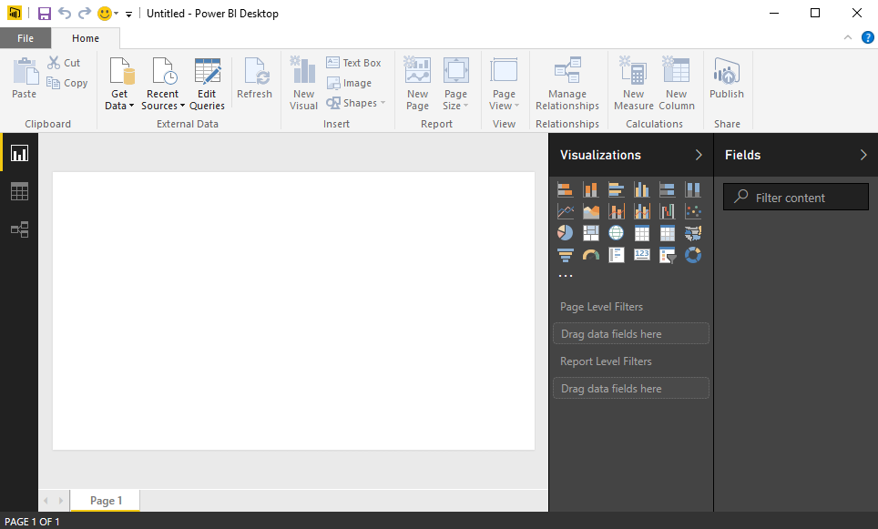

You are now ready to move ahead to the next exercise.

### Exercise 5: Publish a Project with Power BI Desktop

In this lab exercise you will open and publish a PBIX project using Power BI Desktop. Keep in mind that neither this lab nor this workshop has been designed to teach you much about the details involved with designing queries and building data models with Power BI Desktop. It’s assumed that you already have these skills or you will learn how to design datasets and reports with Power BI Desktop outside of this workshop. The purpose of this lab exercise is for you to see how the publish datasets and reports created with Power BI Desktop into workspaces running in the Power BI service.

1. Launch Power BI Desktop if it’s not already running.
2. Open the PBIX project file named **Northwind Retro.pbix**.
   1. Select the **File > Open** command.

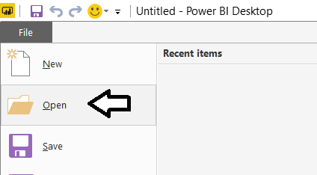

* 1. In the **Open** dialog, navigate to the folder at **C:\Student\PBIX** and double-click **Northwind Retro.pbix**.

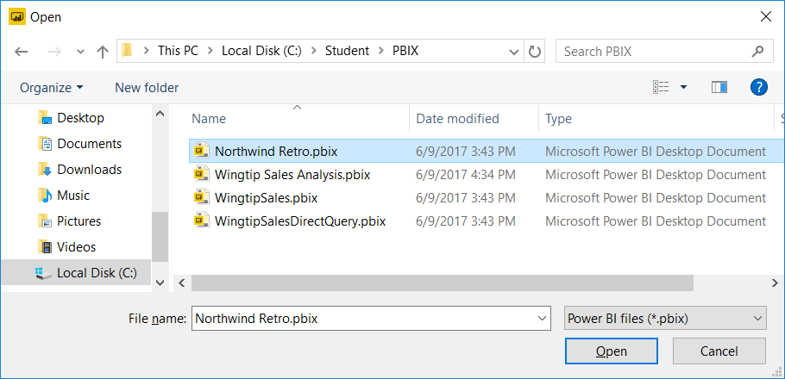

1. Review the contents of the **Northwind Retro** project.
   1. When the **Northwind Retro.pbix** project opens, Power BI Desktop displays it in Report view.

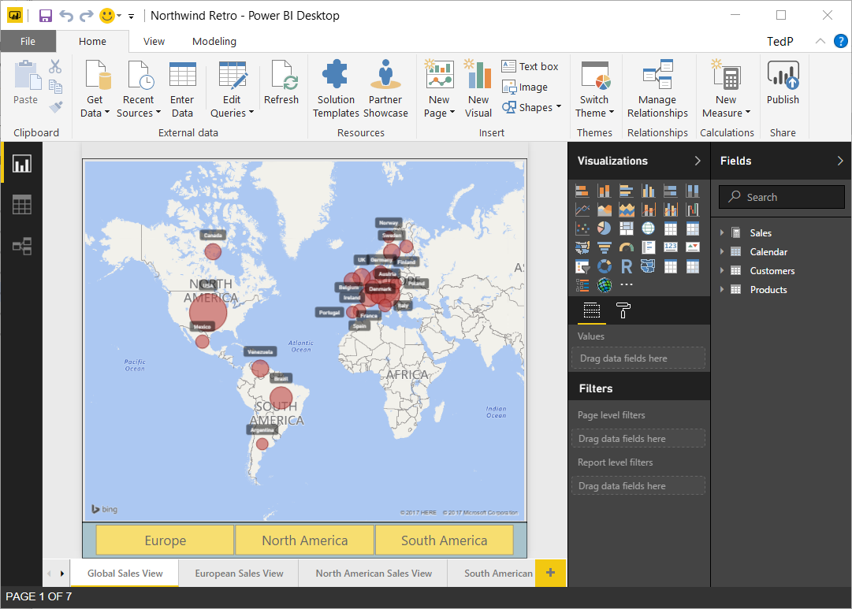

* 1. Inspect all the pages in the report by navigating using the tabbed page navigation at the bottom of the report.
  2. Locate the **Fields** list on the right-hand side of Report view in the main Power BI Desktop window.
  3. You should see four tables named **Sales**, **Calendar**, **Customers** and **Products**.



* 1. Expand each of the tables to in the **Fields** list to see what fields are inside each table.

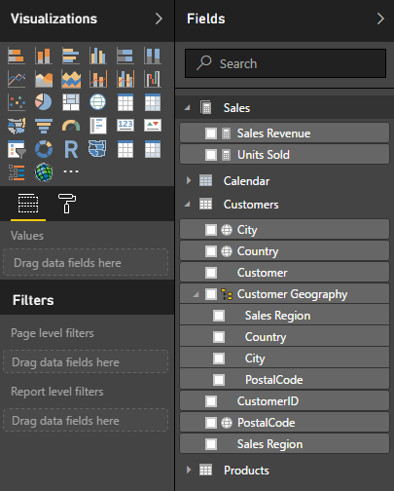

* 1. Switch the project into **Data view** and inspect the data in each of the four tables.

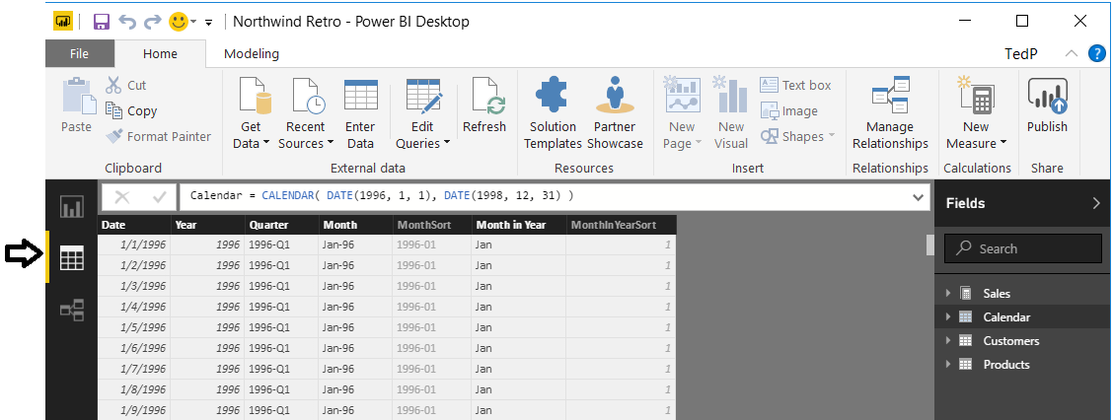

* 1. Switch the project into **Relationship view** to get a high-level picture of the project’s data model.

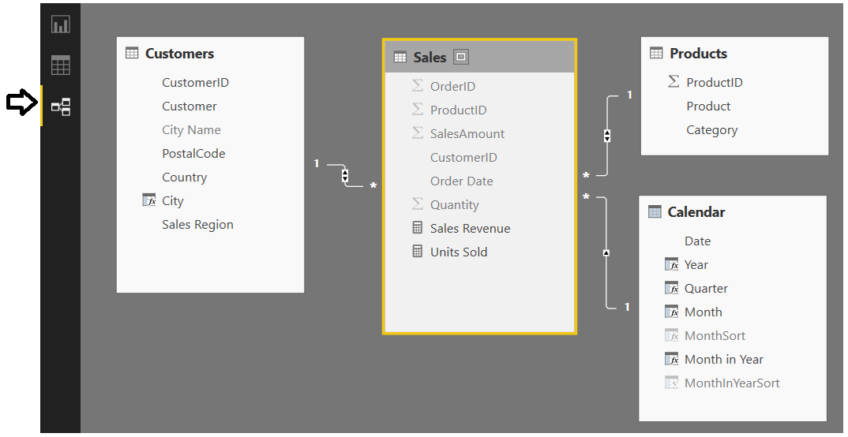

Now it’s time to look at the queries in the project that were used to import the base tables into the project’s data model.

* 1. On the **Home** tab in the ribbon, select the **Edit Queries** command to open the Query Editor window.

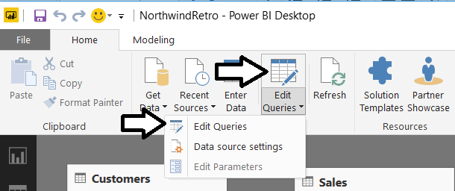

* 1. In the Query Editor window, examine the queries listed in the **Queries** list on the left.

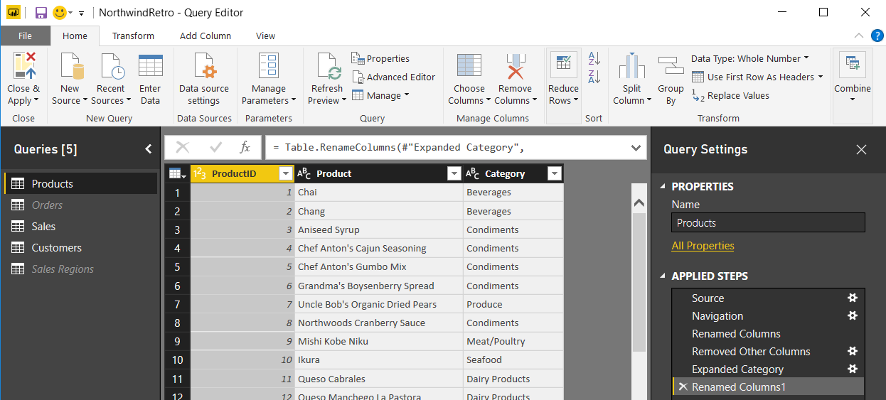

* 1. Select the **Close and Apply** command in the ribbon to close the **Query Editor** window.

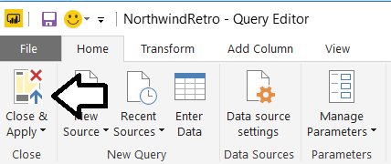

* 1. If you have made any changes to the project, click the **Save** button above the ribbon to save your work.

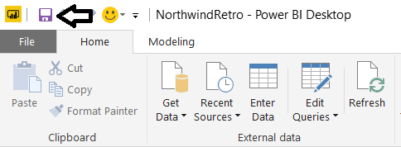

1. Publish the **Northwind Retro** project to your personal workspace in the Power BI service.
   1. On the **Home** tab in the ribbon, click the **Publish** button.

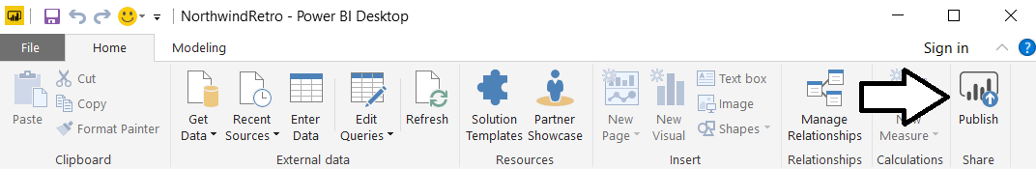

* 1. When prompted to sign in, enter the name of your Power BI user account and click the **Sign in** button.

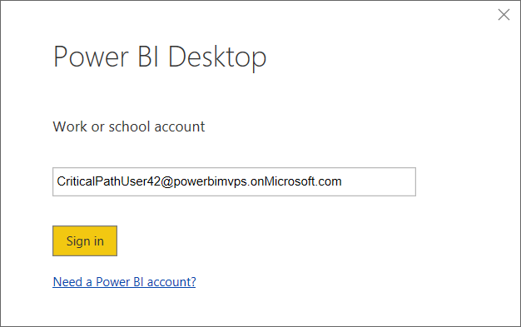

* 1. Power BI when prompted, enter your password and click **Sign in**.

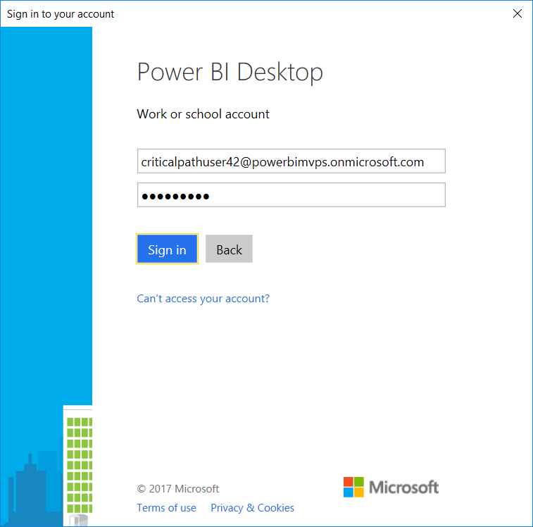

* 1. Wait until you see the notification indicating that the project has been published successfully.

1. Examine what’s been added to your personal workspace in the Power BI service.
   1. Return to the Power BI Service in the browser and verify a new dataset has been created.

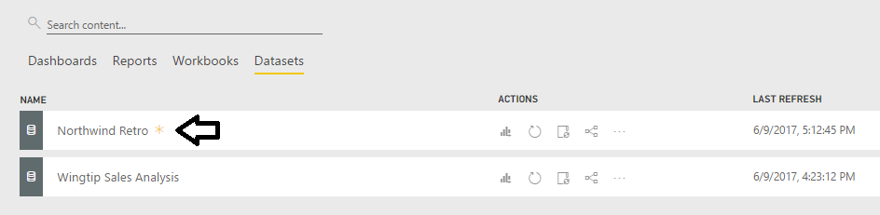

* 1. Navigate to the Reports list and click on the report named **Northwind Retro** to open it.

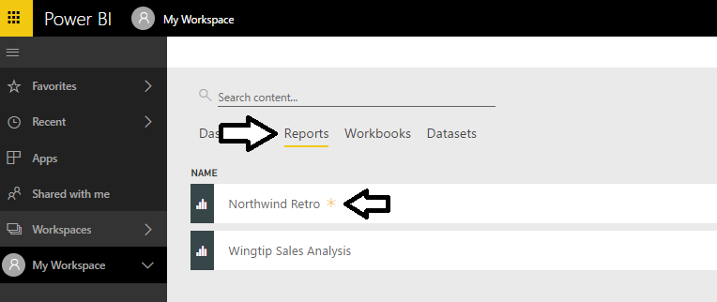

* 1. Take a moment to interact with the report in the browser.

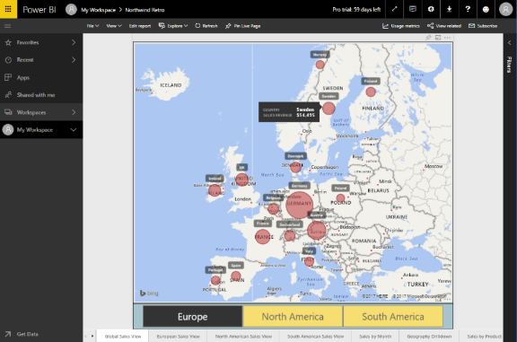

Now you have seen several different techniques for adding content into a Power BI workspace. In the next exercise, you will create a app workspace and then populate it with content. As you will see, adding datasets, reports and dashboards to an app workspace is very similar to adding content to a personal workspace. The big difference is that app workspaces have advantages over personal workspaces such as support for team-based development and app distribution as well as Power BI Premium support for making embedded reports accessible to non-licensed users.

### Exercise 6: Create a New App Workspace to Build a Custom Solution

In this exercise, you will create a new app workspace. After that, you will populate the workspace with datasets, reports and a dashboard just as you did in your personal workspace.

1. Create a new app workspace.
   1. Expand the Workspace menu in the left navigation and select the **Create app workspace** command.

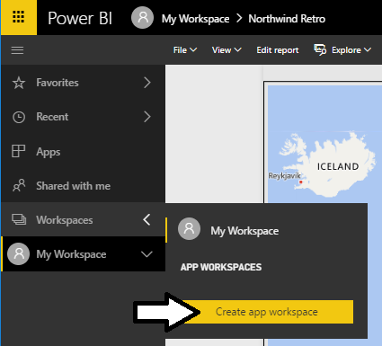

Note that all the students in this workshop are working within the same Power BI tenants. That means everybody must create a app workspace with a unique name. Therefore, you will be asked to use your own name when creating a new app workspace. As long as know two students have the exact same name, nobody should run into naming conflicts.

* 1. Enter your name into the **Name your workspace** textbox.
  2. Add your user account as a workspace member with **Admin** permissions.
  3. Click **Save** to create the new app workspace.

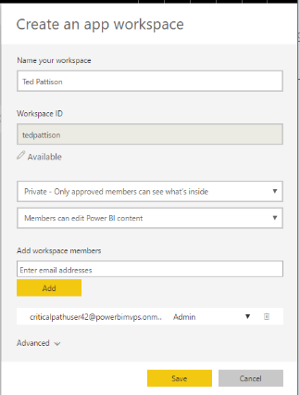

* 1. Power BI should create the new app workspace and navigate you to its welcome page as shown in the following screenshot.

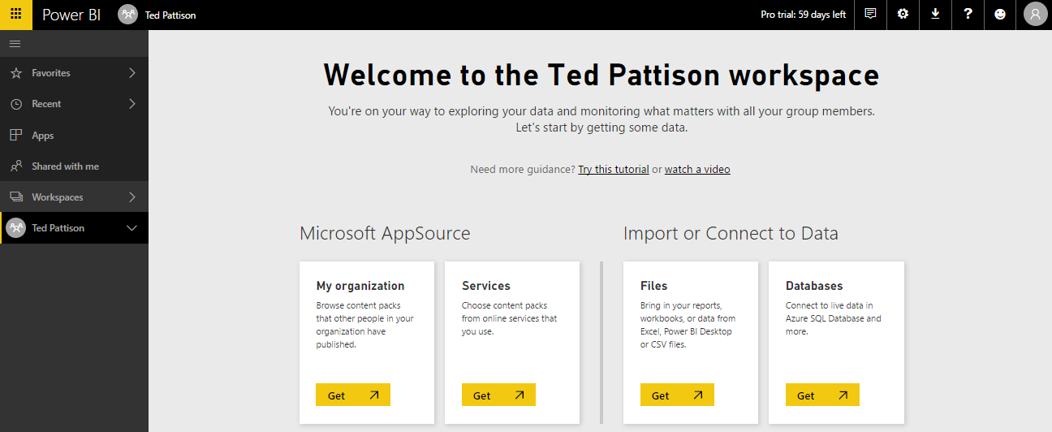

* 1. If you expand the **Workspaces** menu in the left navigation, you can see it provides the Ability to move between your personal workspace and any available app workspace.

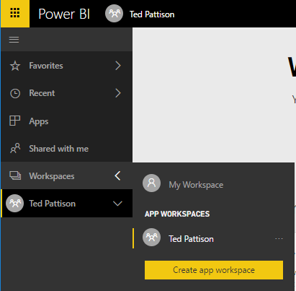

* 1. Navigate you’re your personal workspace.
  2. Now, navigate back to your new App Workspace.

1. Add content to your new app workspace.
   1. On the Welcome page of the app workspace, click the **Get** button in the **Files** section.

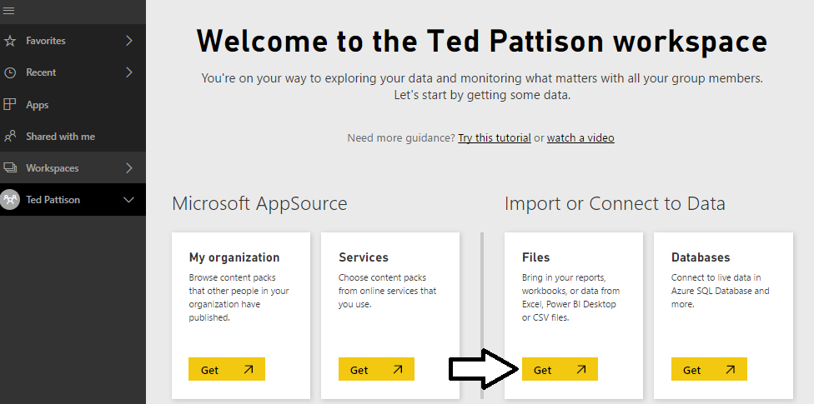

* 1. On the next page you should see several tiles which indicate your choices for the location of the file you would like to connect to or import. Click on the tile with the caption **Local File** and import **Northwind Retro.pbix** from inside your student folder.

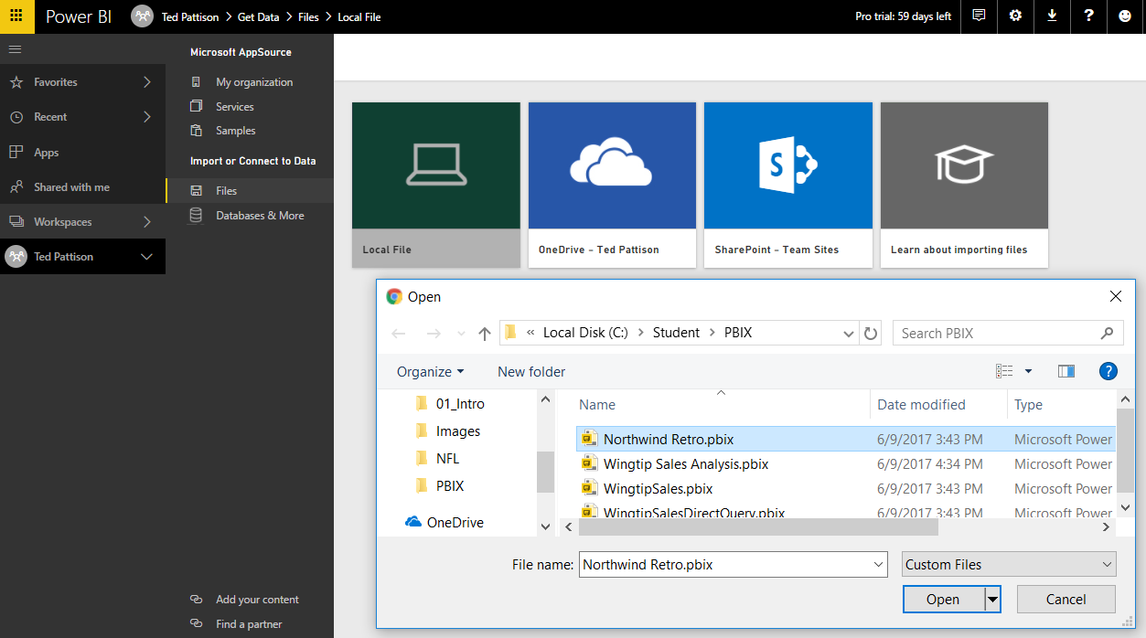

* 1. Repeat the previous step to import the other PBIX project file named **Wingtip Sales Analysis.pbix**.
  2. You should be able to verify that your app workspace now contains two datasets.

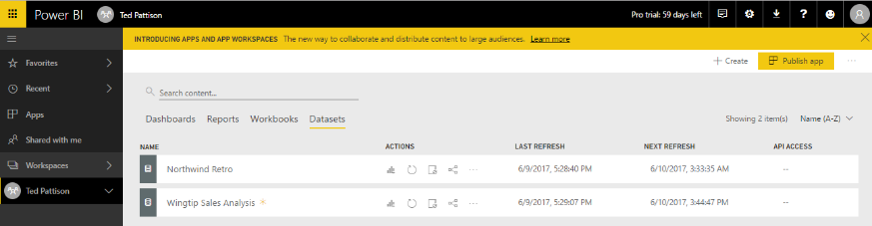

* 1. Delete any dashboard that was created when your imported the two PBIX project files.

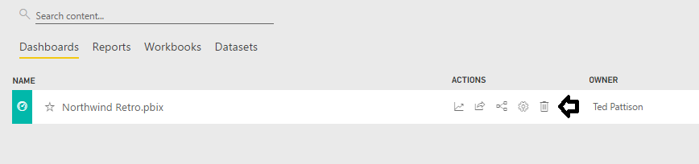

* 1. Switch to **Reports** view and open the report named **Wingtip Sales Analysis**.

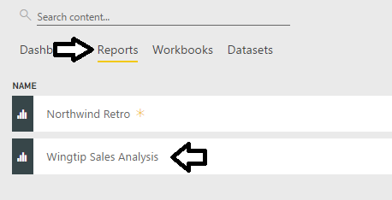

* 1. Just as you did back in lab exercise 3, create a new dashboard named **Wingtip Sales Analysis** by pinning visuals from the report named **Wingtip Sales Analysis**.

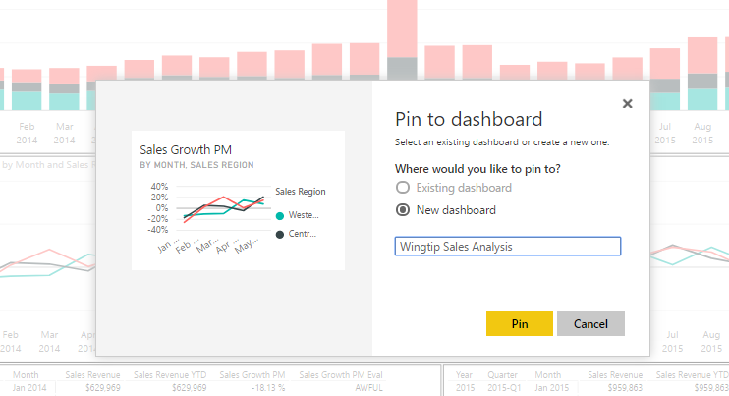

* 1. Add several titles to the dashboard until it resembles the dashboard shown in the following screenshot.

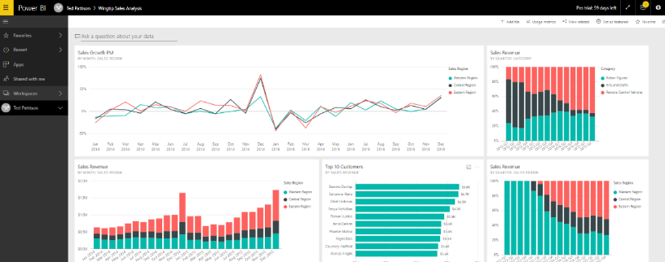

At this point, you have had some hands-on experience working with the app workspace in the Power BI service.

### Exercise 7: Embed a Power BI Report in a Web App using the Publish to Web Feature

Now that you have worked hard in the previous exercise to create an app workspace with content, you will now be rewarded with a final exercise that will provide spontaneous gratification to the developer who lives inside you. More specifically, you will use Visual Studio to develop a custom web page to embed a Power BI report *using only 12 lines of code!*

1. Launch Visual Studio 2017 (or Visual Studio 2015 if that is what you have installed).
2. Create a new Visual Studio project named **HelloPowerBiEmbedding**.
   1. Select the **File > New Project** command.
   2. On the left side of the **New Project** dialog, select **Templates > Visual C# > Web**.
   3. Select the project template named **ASP.NET Web Application**.
   4. Enter a project name of **HelloPowerBiEmbedding**.
   5. Change the Location to C:\Student\Modules\01_Intro\Lab.
   6. Click **OK** to begin the process of creating the new project.

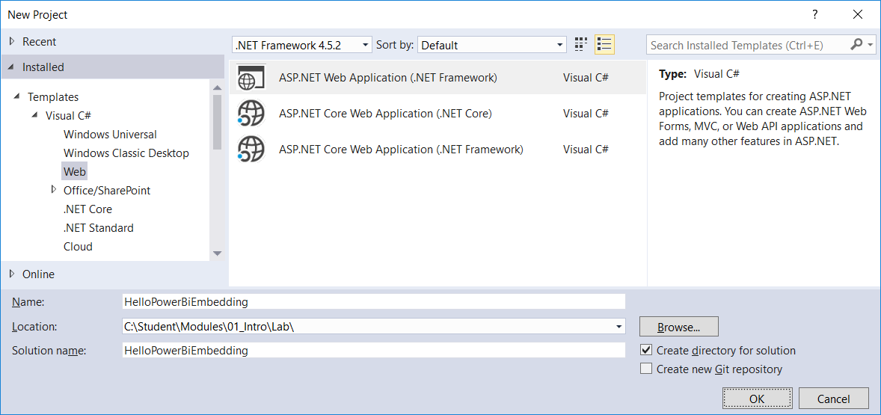

* 1. In the **New ASP.NET Web Application** dialog, select **Empty** and ensure that **Authentication** is set to **No Authentication**.

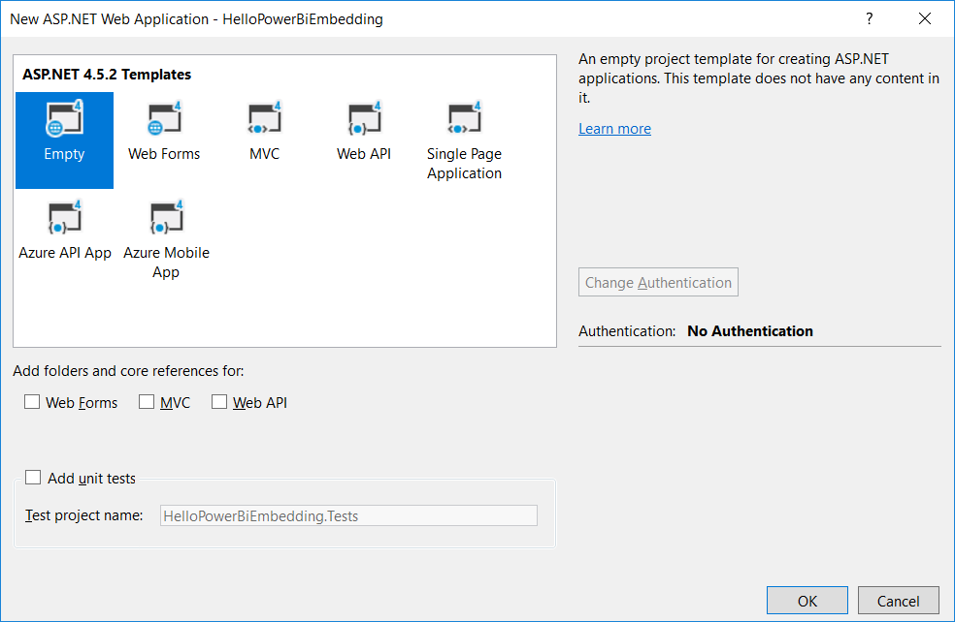

* 1. The **HelloPowerBiEmbedding** project should now be created.

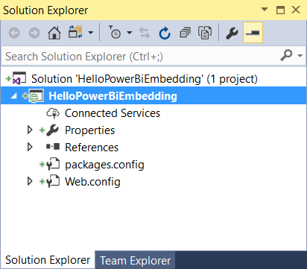

1. Add an HTML web page to the project.
   1. Right-click on the top project node in Solution Explorer and select the **Add > HTML Page** command.

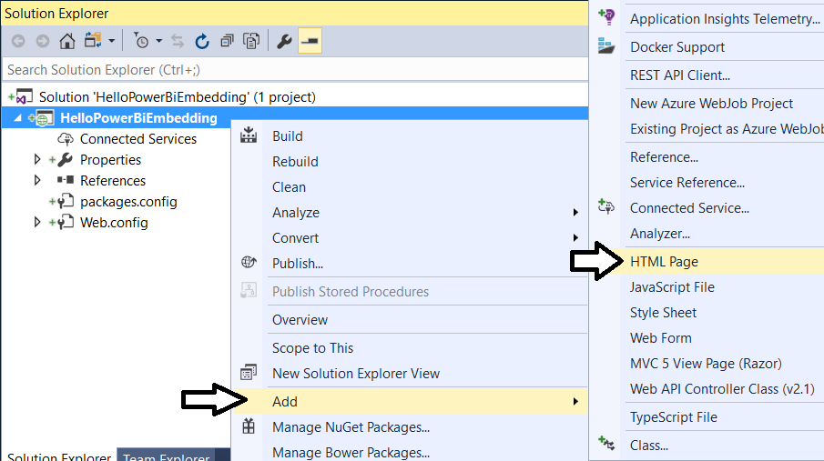

* 1. Give the new page a name of **index.html**.

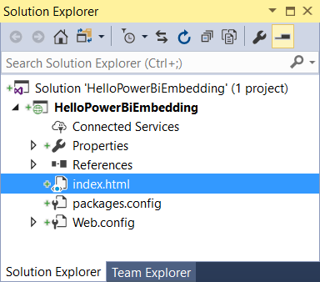

* 1. Delete any existing content inside index.html and replace by copying and pasting the following code listing.

<!DOCTYPE html>

<html>

<head>

<meta charset="utf-8" />

<title>Hello PBI Embedding</title>

</head>

<body>

<h2>Hello Power BI Embedding</h2>

<div>

<!-- TODO: Embed Power BI Report Here-->

</div>

</body>

</html>

1. Test the new HTML page.
   1. Press **{F5}** to start a new Visual Studio debugging session.
   2. You should see the page appear in the browser.

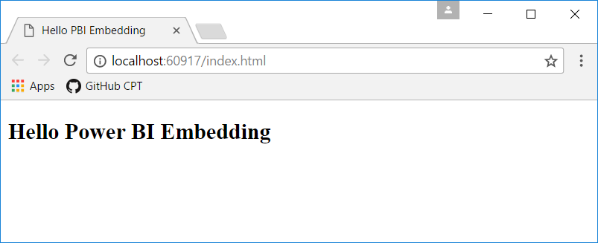

* 1. Close the browser, return to Visual Studio and stop the debugging session.

1. Use the Publish to Web feature to create an embed code and an embeddable iFrame tag
   1. In the browser, return to your app workspace in the Power BI service.
   2. Open the report named **Wingtip Sales Analysis**.

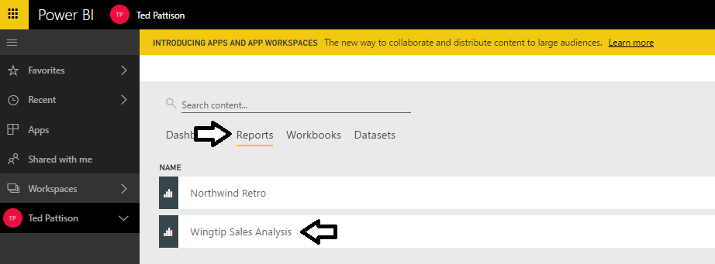

* 1. Drop down the report’s **File** menu and select the **Publish to Web** command.

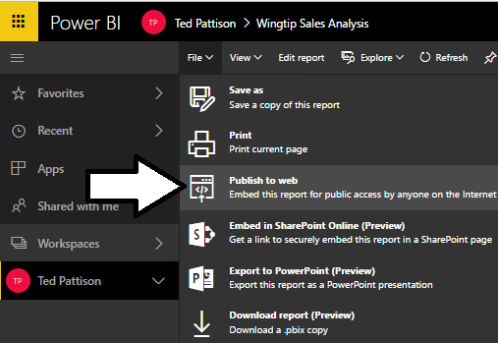

* 1. When prompted with the **Embed in a public website** dialog, click the **Create embed code** button.

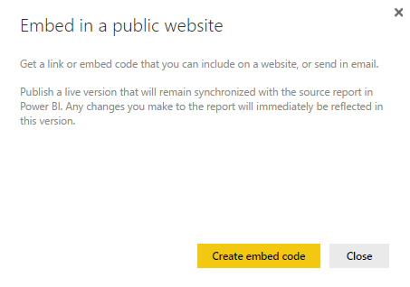

* 1. On the next page, click the **Publish** button.

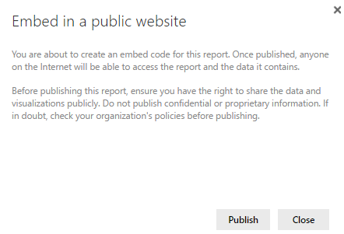

* 1. Inspect what is displayed to you on the **Success!** Page.

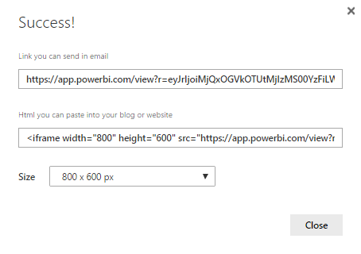

* 1. Select the contents of the **Html you can paste into your blog or website** textbox and copy it to the Windows clipboard,

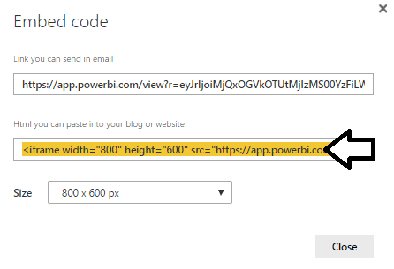

* 1. Return to Visual Studio and paste the HTML snippet with the iFrame tag into **index.htm**.

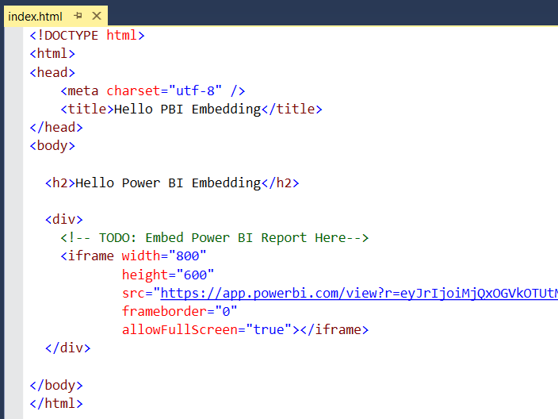

* 1. Press **{F5}** to start a new Visual Studio debugging session.
  2. You should see the page appear in the browser the embedded Power BI report.

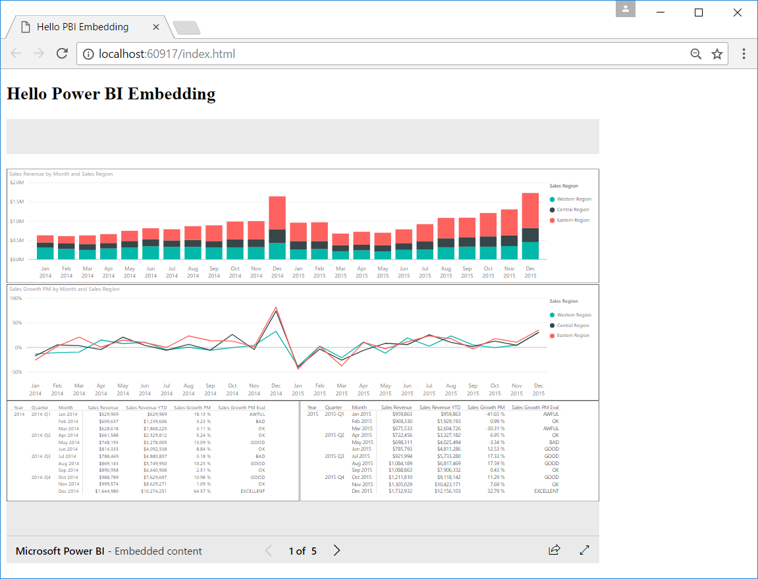

You have now complete this set of lab exercises. When we told you that you would only have to write 12 line of code, you probably didn’t expect 11 of those lines to be the basic HTML code for a simple web page. This demonstrates how easy it is to embed a Power BI report on a web page using anonymous access. The type of report and dashboard embedding you will learn about later today will be significantly more complicated and require many more developer skills than were required to complete this lab.